NCCA’s ‘Guide To How Carpet Protector Really Works’ Instruction’s

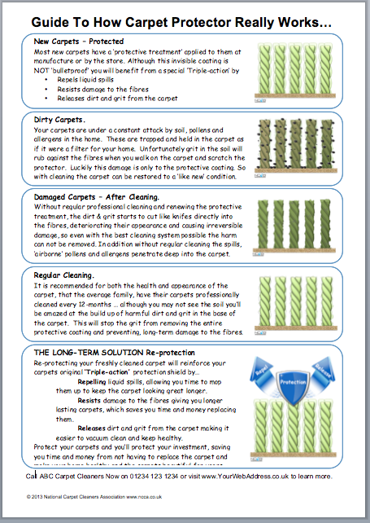
Below on the next page you’ll find the FREE Word .docx template for the ‘Guide To How Carpet Protector Really Works…’

It explains with images the five steps of how carpet protector works. These include …

- New Carpet – How ‘most’ carpets are protected
- Dirty Carpets – How the carpet is the filter to the home and needs to be cleaned to remove both dirt and allergens
- Damaged Carpets – How they become damaged without regular cleaning
- Regular Cleaning – Recommending re-cleaning and re-protecting every 12-months
- Long-Term Solution – How carpet protection will protect their investment.

This is not a glossy printed flyer (most suppliers can sell you those), this is more of a technical sheet to help you to explain to the customer how protection works. It works by educating the customer and not an in-your-face sales tool.

I recommend you read it make changes where necessary. Add your contact details on the bottom and print off on good quality (120g+) paper.

Used on it’s own this sheet will work great, but with a copy of the ’12-Month Warranty Certificate’ it works fantastic.

The only thing now is for YOU to USE it and offer carpet protection to every customer you quote for.

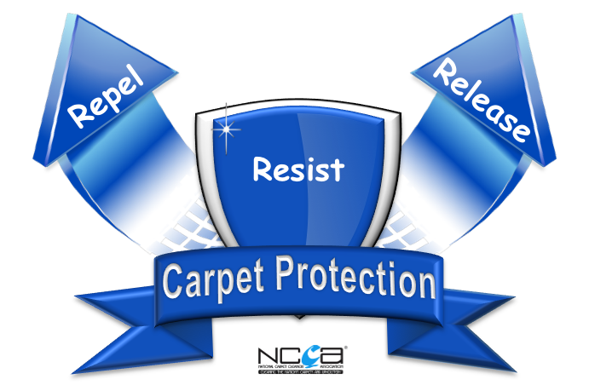
Good Luck

Keith Robertson
Marketing Director.

PS. As a NCCA member the images and logos are free for you, to use as you wish. These may give you ideas to have your own drawn in your colours and incorporating your own logo.

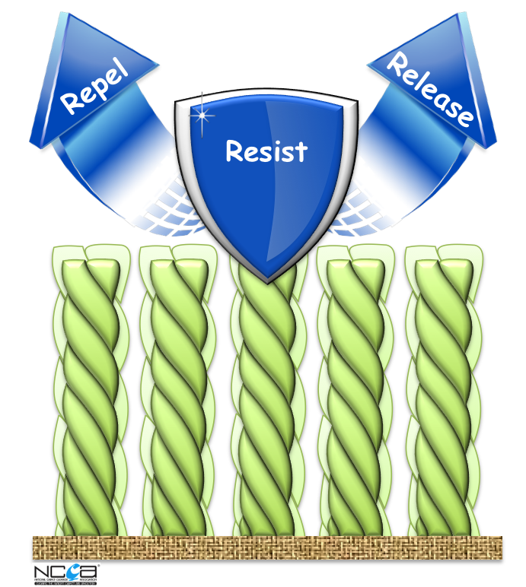
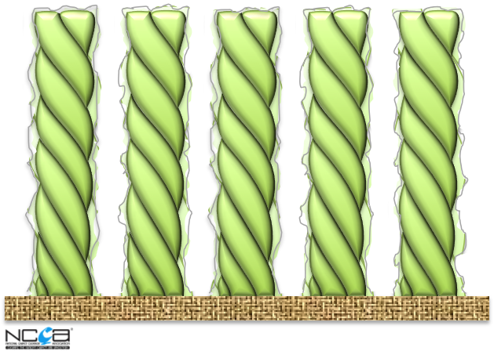
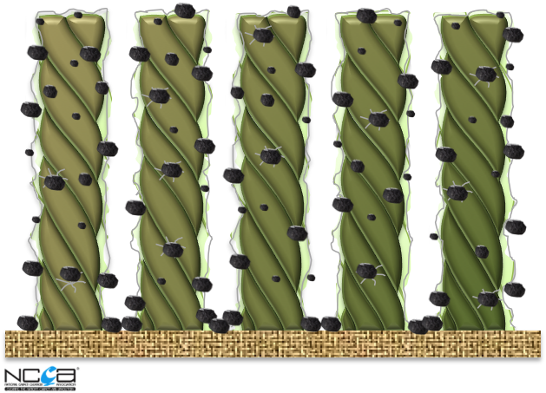
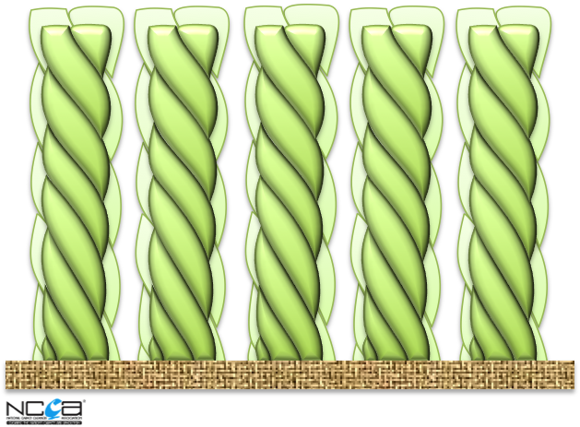
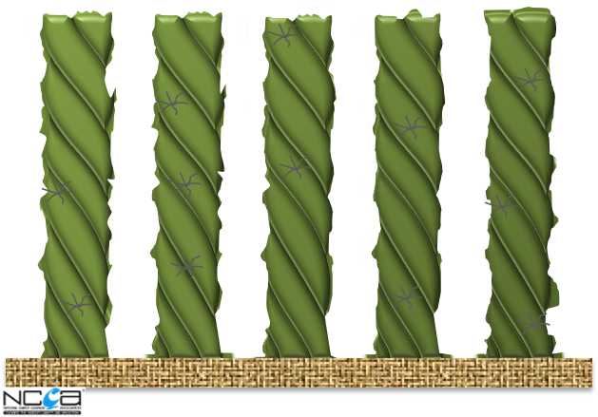
New Carpets – Protected
Most new carpets have a ‘protective treatment’ applied to them at manufacture or by the store. Although this invisible coating is NOT ‘bulletproof’ you will benefit from a special ‘Triple-action’ that…
- Repels liquid spills
- Resists damage to the fibres
- Releases dirt and grit from the carpet

Dirty Carpets.
Your carpets are under a constant attack by soil, pollens and allergens in the home. These are trapped and held in the carpet as if it were a filter for your home. Unfortunately grit in the soil will rub against the fibres when you walk on the carpet and scratch the protector. Luckily this damage is only to the protective coating. So, with cleaning, the carpet can be restored to a ‘like new’ condition.

Damaged Carpets – After Cleaning.
Without regular professional cleaning and renewing the protective treatment, the dirt & grit starts to cut like knives directly into the fibres, deteriorating their appearance and causing irreversible damage, so even with the best cleaning system possible the harm can not be removed. In addition without regular cleaning the spills, ‘airborne’ pollens and allergens penetrate deep into the carpet.

Regular Cleaning.
It is recommended, for both the health and appearance of the carpet, that the average family, have their carpets professionally cleaned every 12-months … although you may not see the soil you’ll be amazed at the build-up of harmful dirt and grit in the base of the carpet. This will stop the grit from removing the entire protective coating and preventing, long-term damage to the fibres.

THE LONG-TERM SOLUTION Re-protection
Re-protecting your freshly cleaned carpet will reinforce your carpets original ‘Triple-action’ protection shield by…
- Repelling liquid spills, allowing you time to mop them up to keep the carpet looking great longer.
- Resists damage to the fibres giving you longer lasting carpets, which saves you time and money replacing them.
- Releases dirt and grit from the carpet making it easier to vacuum clean and keep healthy.
Protect, your carpets and you’ll protect your investment, saving you time and money from not having to replace the carpet and make your home healthy and the carpets beautiful for years.
Call ABC Carpet Cleaners Now on 01234 123 1234 or visit www.YourWebAddress.co.uk to learn more.
© 2013 National Carpet Cleaners Association www.ncca.co.uk

Guide To How Carpet Protector Really Works…

