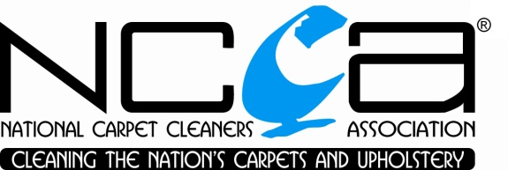
ADVANCED MEMBERSHIP APPLICATION FORM

To be eligible for Advanced Membership of the National Carpet Cleaners Association, the following criteria need to be met:

- The company has been a fully registered NCCA member for at least two years directly prior to arranging this application

- The Owner or an employed technician has completed training in Advanced Spot & Stain Removal and at least one other recognised course (in addition to the entry level carpet/upholstery cleaning training) during the company’s time as a member (this representative will be allocated as the Head Technician)

- The company fulfils all other requirements for renewal of NCCA membership, as follows:
  - Current Public Liability/Treatment Risk insurance cover
  - Compliance with the One to One Rule
  - Signed acceptance and compliance with the NCCA Health & Safety Declaration

To apply for Advanced Membership please complete the below form and return this document to the NCCAS office.

Company Name

Mem. Number

Head Technician

Qualifications and Dates
(provide details of required qualifications for Head Technician as described in Point 2 above, along with any other recognised training)

IMPORTANT: Evidence of all qualifications must be provided with this application form. The NCCA will be unable to accept applications that are not accompanied by certificates or other confirmation that the above courses have been completed. The NCCA office may be able to confirm qualifications gained via the Association, please contact the office if you require any clarification on NCCA training.

Name

Date

v3 220116

