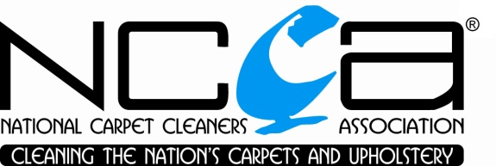
SENIOR MEMBERSHIP APPLICATION FORM

To be eligible for Senior Membership of the National Carpet Cleaners Association, the following criteria need to be met:

- The company has been a fully registered NCCA member for at least seven years directly prior to arranging this application

- The Owner or an employed technician has completed training in Advanced Spot & Stain Removal and at least four other recognised courses (in addition to the entry level carpet/upholstery cleaning training) during the time the company has been registered with the NCCA (this representative will be allocated as the Head Technician)

- The company fulfils all other requirements for renewal of NCCA membership, as follows:
  - Signed acceptance and compliance with the NCCA Articles of Association and Code of Practice
  - Current Public Liability/Treatment Risk insurance cover
  - Compliance with the One to One Rule
  - Signed acceptance and compliance with the NCCA Health & Safety Declaration

IMPORTANT: The Head Technician will be required to continue gaining education and qualifications throughout the company’s registration as a Senior Member. By applying for Senior Membership the company agrees to confirm attendance of at least one additional course/industry event by the Head Technician within every three year period from the date of becoming a Senior Member. The Association can be consulted as to whether a particular industry event qualifies. Failure to meet this requirement may result in the company losing its status as a Senior Member.

To apply for Senior Membership please complete the below form and return this document to the NCCA office.

Company Name

Mem. Number

Head Technician

Qualifications and Dates
(provide details of required qualifications for Head Technician as described in Point 2 above, along with any other recognised training)

v3 220116
Qualifications and Dates continued

IMPORTANT: Evidence of all qualifications must be provided with this application form. The NCCA will be unable to accept applications that are not accompanied by certificates or other confirmation that the above courses have been completed. The NCCA office may be able to confirm qualifications gained via the Association, please contact the office if you require any clarification on NCCA training.

Name

Date

v3 220116

